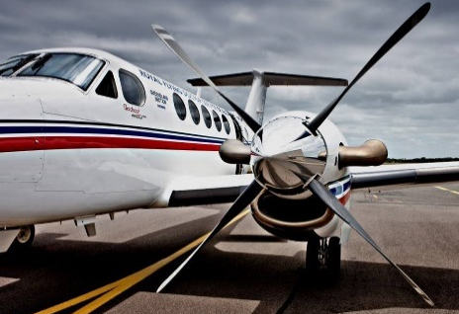
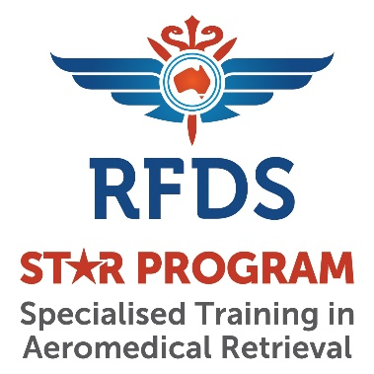

23 – 24 November, 2019
Brisbane

http://rfds.co/StarProgram

Essential Aspects of
Aeromedical Retrieval

REGISTRATION FORM

Your details: (please print)

Title: First name or nickname: Last name

Preferred name to appear on certificate (if different):

Mobile Number: Home phone: Fax number

Email:

Please tick here to indicate your permission to include your contact name and this email address on any delegate list circulated to the delegates. This email address will NOT be provided to any persons outside of this group.
Occupation:

Company/Organisation:

Retrieval Experience: Yes No

Address Line 1:

Address Line 2:

City/Town:

State: Postal Code

Date of Birth: (dd/mm/yyyy) Where did you hear about the course?

Emergency contact:

First name:

Last name:

Relationship:

Preferred contact number:

Additional contact number (if preferred number cannot be reached):

Dietary requirements:
* Please indicate if any:

Vegetarian Gluten Free Food allergies: ________________________________
please list
Registration costs:

Registration Costs payable at the time of booking:

Early Bird Registration fee (by 11th October 2019) AU $2,625 (inc GST)
Full Registration fee AU $2,880 (inc GST)

Note: this document will become a Tax Invoice when payment is made in full. RFDS ABN (80 009 663 478)

Payment details:

Our preferred method of payment to us is via credit card (accepted cards below). On receipt, we will send you a confirmation of your reservation.

Credit card: (please indicate)

Mastercard Visa Card American Express Diners Club

Name of Cardholder:
Card Number: |  | Expiry Date:
Signature:

Alternatively, please contact us by email for our banking details for direct deposit.

Cancellation notice and charges:

Cancellations must be notified to RFDS (Qld Section) in writing as soon as possible. Your notice of cancellation will take effect as soon as it is received. As we incur costs from the time we first accept your registration, we will apply the following cancellation charges:

Days prior to the course when cancellation received | Cancellation charge (% of total cost)
> 60 days | 10%
30 – 59 days | 50%
Less than 29 days | 100%

Terms and conditions:

The total registration costs are payable at the time of the booking.

I agree and consent that RFDS (Qld Section) may use, including sharing with third parties, your contact information (ie your name, physical / postal address and/or other contact details) for all purposes directly connected with your course registration.

Filming and photo release consent (optional):
I hereby grant the Royal Flying Doctor Service (Qld Section) (RFDS) the irrevocable right to use my name/photograph/image/ audio recording/video recording and likeness in all forms and manner (“My Image”) for the purposes of advertising, media publicity, publication, general display or for any other RFDS purposes in whole or in part, including but not limited to publication on Internet web sites, broadcasts and any other publications as released to or by RFDS (“Publication”).

I waive any interest that I may have in the copyright to My Image now or at any future time and acknowledge that I am not entitled, nor shall in the future be entitled, to receive any payment or consideration in respect of it and agree to make no claim against RFDS for any payments for the Publication of My Image.

I understand RFDS cannot control unauthorised use of My Image by persons not associated with RFDS upon the Publication of My Image.

I forever waive any right to inspect or approve any Publication of My Image by RFDS.

I release and indemnify RFDS from any loss, damage, costs, expense, or claim (including consequential loss) connected with the Publication of My Image, including action for defamation, libelous material, breach of privacy, or copyright.
Consent:
I have read the filming and photo release consent carefully and fully understand its meaning and implications.

Liability:
RFDS (Qld Section) does not warrant the accuracy, completeness, or fitness for a particular purpose of any services provided by any supplier and to the maximum extent permitted by any law disclaims all implied warranties in connection with same. In no event shall we be liable for any injury, loss, claim, damage or any incidental or consequential damages, including but not limited to lost profits or savings, arising out of or in any way connected with the course arrangements made.
I have read the liability clause carefully and fully understand its meaning and implications:

Agree Disagree (please indicate)

I have read and understood the terms and conditions and cancellation notice and charges and agree to be bound by them.

Completed forms should be emailed to: star@rfdsqld.com.au or posted to:

RFDS STAR Program
Royal Flying Doctor Service of Australia (Queensland Section)
12 Casuarina Street
Brisbane Airport Qld 4008
Tel: (07) 3852 7521 Fax: (07) 3860 1122 Website: http://rfds.co/StarProgram

