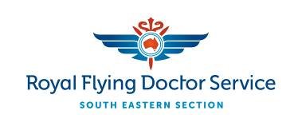

Media Release Embargoed unitl 18.30 AEST, 8 April 2016

Australian First - Flying Doctor welcomes touchdown of aeromedical innovation project

The Royal Flying Doctor Service South Eastern Section (RFDS SE) has welcomed
today’s announcement by New South Wales Premier, Mike Baird, that the State Government will make a collaborative contribution of $2.5 million towards an innovative new multipurpose facility at the RFDS SE’s Dubbo Base.

This new $18 million facility will allow the RFDS SE to accommodate an aeromedical simulation and training facility, a state-of-the art flight training centre for Beechcraft Kingair aircraft, and a Flying Doctor tourism and visitor centre, all focused on innovation.

Speaking from Israel, where he is accompanying the Premier’s trade delegation, Greg Sam, RFDS SE Chief Executive Officer, welcomed the prospect of new services and facilities that would directly benefit the Flying Doctor, their patients across the region, and other health and aviation providers. This initiative will also have a positive flow-on effect for local jobs and businesses through increased tourism and demand for accommodation and other services.

“I would like to thank Mike Baird, Elbit Systems of Australia, Dubbo City Council and our longstanding community partners, the Dubbo Support Group, without whom this initiative would not be possible,” said Mr Sam.

“The ability to train flight staff and medical staff simultaneously allows us to delivery an even higher level of aeromedical care for our patients and a safer operating environment for our staff.

“The Dubbo Support Group have supported us ever since we opened our Dubbo base in 1999, and including this generous contribution of $1.1 million to the new facility, have raised over $3 million to date and helped us develop a model for community/health provider partnerships.”

“This announcement is great news for the people of Dubbo and Central Western New South Wales and for the RFDS SE. We have been expanding our facilities and clinic services in Dubbo as part of our 2015-19 strategic plan, aimed at reducing the well-documented gap in health and wellness between those living in remote, rural and regional areas and those in the cities.

“Currently many of our staff train overseas. Having world-class, state-of-the-art facilities within our existing Dubbo Base will promote medical excellence in healthcare delivery and support community engagement. It will also enable us to train our fixed-wing pilots and medical staff in this highly specialised branch of medicine quicker and more economically.”

NSW Premier Mike Baird inspected one of the simulators with Mr Sam during a visit to Elbit’s facility in Netanya, north of Tel Aviv, during his official visit to Israel.

“The Royal Flying Doctor Service is a beloved Australian institution and the NSW Government is proud to support the construction of this new facility at Dubbo,” Mr Baird said.

“This project is an Australian first. It will be the only facility in Australia to provide aeromedical training for pilots as well as medical staff, to help ensure the continued success of the world-class service in regional NSW and Australia.”

The flight-training simulator will be installed and operated by Elbit Systems of Australia, a subsidiary of Elbit Systems, an Israeli high technology company that develops and supplies a wide range of innovative technology products and services.

Dan Webster Elbit Systems of Australia’s Managing Director said: “The Beechcraft King Air B200 simulator is a perfect example of Elbit Systems’ high technology and innovate solutions that are widely used in order to save lives. The cooperation between Elbit Systems, the RFDS SE and the New South Wales government is an example of our commitment to the Australian society and I hope more cooperation will follow. “

Construction work is scheduled to start on the new facilities, located on Dubbo airport, in the near future and they are expected to open in 2017, Dubbo City Council has supported the RFDS for many years and their support for this project is essential.

“We are delighted to be able to further deliver on the promise made a few years ago by the RFDS SE board to increase facilities and services at Dubbo, and are very grateful to all those involved who’s support has enabled this new facility,” said Mr Sam.

- ENDS -

For more information or photographs, contact:

RFDS SE;
Nick Bleszynski, Media Consultant, RFDS (South Eastern Section) on 0403 931 291 or nick.bleszynski@rfdsse.org.au or
Michelle Lauder, Marketing communications manager, RFDS (South Eastern Section), 0407 583 854, michelle.lauder@rfdsse.org.au

Premier of NSW;
Olivia Suzanski, Olivia.suzanski@premier.nsw.gov.au 0448 994 631

ABOUT THE ROYAL FLYING DOCTOR SERVICE
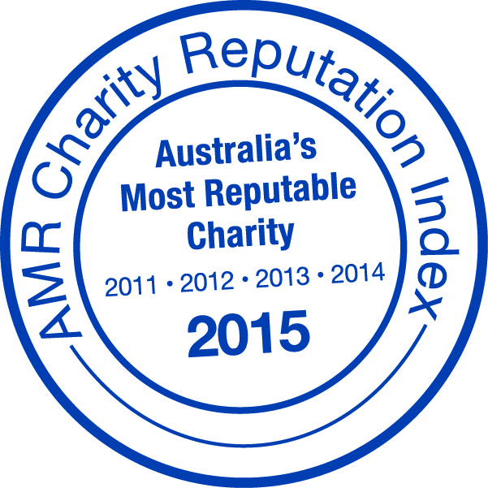
The not-for-profit Royal Flying Doctor Service has been taking the finest care to the furthest corners of Australia since 1928. The service provides 24 hour emergency cover to 90% of the Australian continent, via a modern fleet of specially equipped aircraft. In the past year, the South Eastern Section conducted almost 5,000 clinics, took over 6,400 telehealth calls, had over 53,500 patient contacts and transported almost 8,500 patients.

