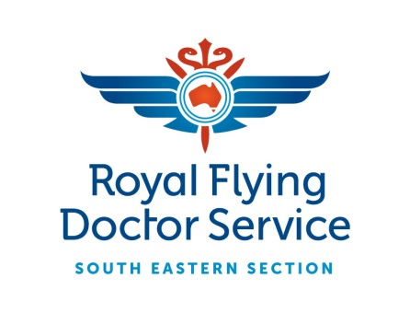

Media Release
Wednesday, 20 April 2016
The Broken Hill PCYC Cowboys Junior Rugby League team will be the first side to proudly display the Royal Flying Doctor Service South Eastern Section (RFDS SE) logo on their jerseys in an exciting new charity partnership announced today in Broken Hill.

Country Rugby League and Royal Flying Doctor Service officials came together today at the RFDS Bruce Langford Visitors Centre to announce the new partnership which aims to promote the invaluable service the RFDS provides to communities throughout remote, rural and regional New South Wales.
CRL CEO Terry Quinn believes the CRL and RFDS partnership is a perfect fit for the communities which they serve.
“The CRL and Royal Flying Doctor Service play an important role in the communities that they serve and to be able to promote the RFDS through Rugby League in Regional NSW is a fantastic opportunity,” said Quinn.
“The Outback Rugby League and Broken Hill PCYC Cowboys Junior Rugby League will wear the RFDS logo on their jerseys for the duration of the season and we hope to see this replicated in a number of areas in the near future.
“The RFDS covers 90% of the Australian continent and provide an irreplaceable service to the people of this country and we are proud to be associated with them through this partnership.”
Royal Flying Doctor Service Broken Hill Base Manager Steve Martin admits he is excited at the prospect of partnering with the CRL.
“We are delighted to announce this partnership with Country Rugby League that kicks off here today with the Broken Hill PCYC Cowboys,” said Martin.
“The Royal Flying Doctor Service is proud to be a part of the communities which we serve, and we understand that Rugby League also plays a big role in many of these communities and this partnership is also recognition of that.
“I understand the Cowboys players and families chose the RFDS to support this season and we are honoured to be chosen as a charity partner for the CRL in 2016.”
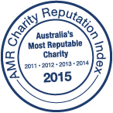
ABOUT THE ROYAL FLYING DOCTOR SERVICE
The not-for-profit Royal Flying Doctor Service has been taking the finest care to the furthest corners of Australia since 1928. The service provides 24 hour emergency cover to 90% of the Australian continent, via a modern fleet of specially equipped aircraft. In the past year, the South Eastern Section conducted almost 5,000 clinics, took over 6,400 telehealth calls, had over 53,500 patient contacts and transported almost 8,500 patients.
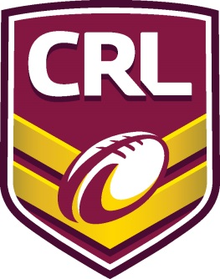

For further queries, please contact:
Adam Kidd
0424 612 856
akidd@crlnsw.com.au

