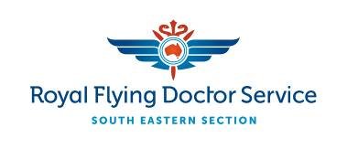

Media Release 17 May 2017
Flying Doctor embraces new medical simulator technology
The Royal Flying Doctor Service (RFDS) has witnessed some unprecedented technological changes during its 89 year history. A willingness to embrace new technology and medical innovation has enabled the Service to evolve into a comprehensive 24/7 aeromedical provider. Every day across Australia the Flying Doctor performs emergency evacuations and facilitates vital primary healthcare services to regional, rural and remote communities.
Earlier this year, the homemade Suction Assisted Laryngoscopy Airway Decontamination Device (SALAD) a.k.a. “the vomiting doll” built by Dr Andy Caldin of the RFDS South Eastern Section (RFDS SE), hit the headlines https://www.youtube.com/watch?v=T4MyXxtMS2Y . This innovation has been followed by the delivery of Apollo, a male state-of-the-art medical mannequin, and a female called Lucina.
“Medical simulators have been around for decades, but advances in technology have made them even more lifelike and sophisticated,” said Dr Caldin.
“Lucina, named after the Greek goddess of childbirth, can actually give birth by way of a complex mechanism inside the abdomen. This allows us to simulate everything from a normal delivery to complicated, life-threatening scenarios for both mother and baby. This is vital training for our Flight Nurses, who are all trained midwives.
“As we demonstrated with the SALAD mannequin, the ability to put medical staff in critical situations and then re-evaluate their performance after the event, makes these simulators an incredibly valuable training tool.
“They will help our medical teams to develop and maintain their medical skills in readiness for real-life emergencies.”
Medical staff at Broken Hill Base will get a chance to see Apollo close-up at a full simulation demonstration/ training session on Thursday, 18 May. They will be shown how the software that controls these models can mimic the physiology and pathology of real-life patients.
“Tomorrow we will be mocking up an emergency situation following a car accident that will allow us to test our medical skills and procedures under pressure,” said Dr Caldin.
For more information or photographs, contact:
Nick Bleszynski, Media Consultant, RFDS (South Eastern Section) on 0403 931 291 or nick.bleszynski@rfdsse.org.au
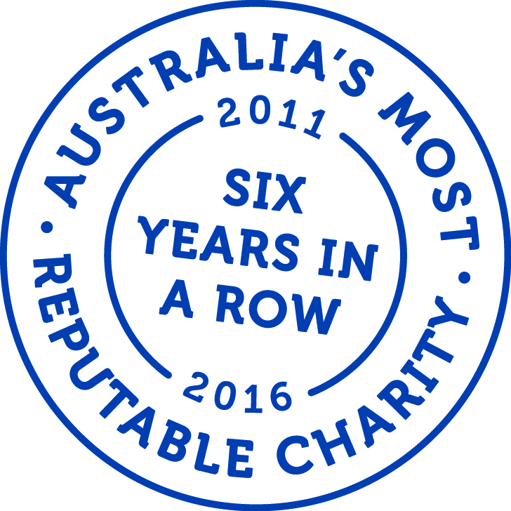

ABOUT THE ROYAL FLYING DOCTOR SERVICE
The not-for-profit Royal Flying Doctor Service has been taking the finest care to the furthest corners of Australia since 1928. The service provides 24 hour emergency cover to 90% of the Australian continent, via a modern fleet of specially equipped aircraft. In the past year, the South Eastern Section facilitated almost 4,500 clinics, took over 5,500 telehealth calls, had over 49,100 patient contacts and transported almost 8,200 patients.

